Step 1: install ‘Html Publisher Plugin’

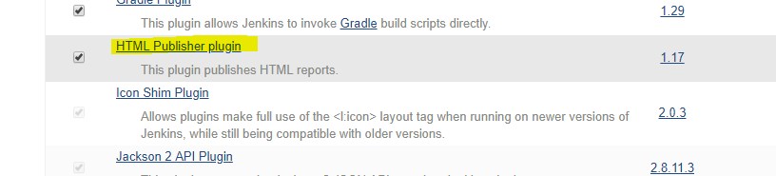

Step 2: Open pipe line syntax from job and set up the ‘publishHtm’ groovy syntax as follow:

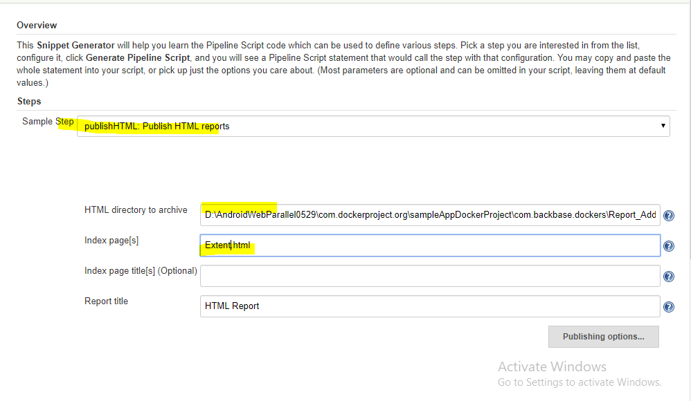

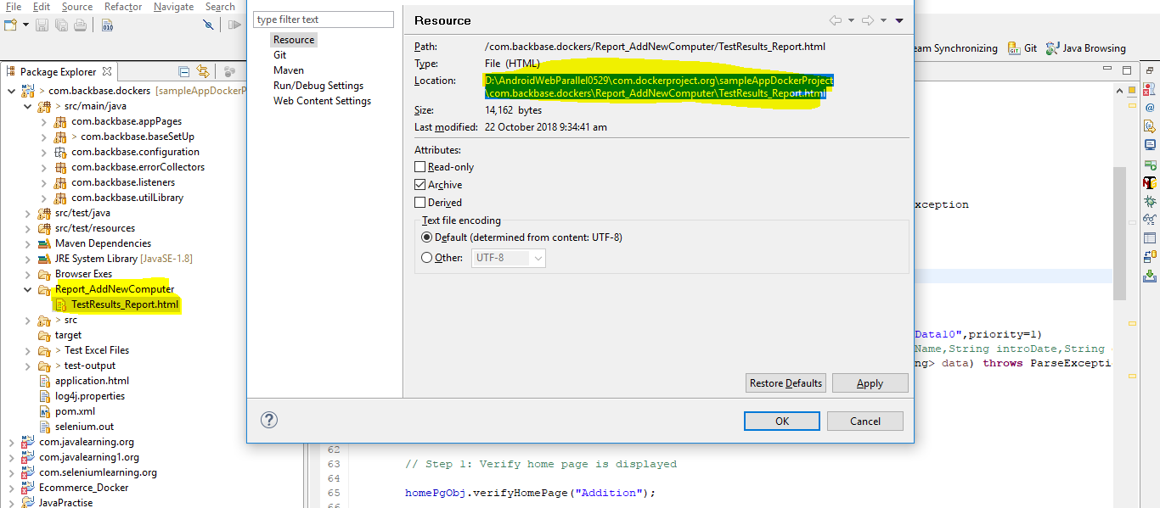

Step 3: Start the Jenkins server by using the following command:

java -Dhudson.model.DirectoryBrowserSupport.CSP="" -jar jenkins.war

If the Jenkins was not run with the above command then the extent report will be displayed in raw format not in graphical user interface.

Step 4: Run the job and extent report will be generated as below:

